Trevor McLaurine

6/1/2023

Assignement 2.2

**ORDs**

**NodeShopper**

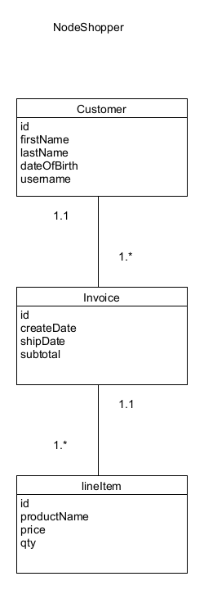

**NodeTech**

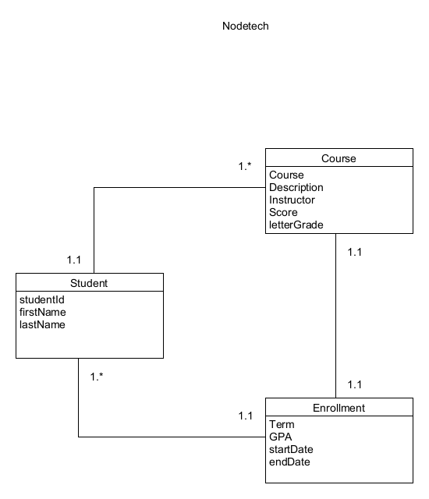

**JSON**

**NodeShopper**

{

"NodeShoppers": {

"customer": {

"_id": "10001110101",

"firstName": "Ronald",

"lastName": "Jenkees",

"dateOfBirth": "1/2/1995",

"username": "funkmaster9000"

},

"invoice": [{

"_id": "0123",

"createDate": "4/5/2023",

"shipDate": "4/6/2023",

"subtotal": "294.65",

"lineItems": [{

"_id": "8675309",

"productName": "Red Ryder BB Gun",

"price": "199.99",

"qty": "1"

},

{

"_id": "66462323",

"productName": "Red Ryder BB Gun Pellets",

"price": "24.99",

"qty": "2"

}]

},

{

"_id": "594939",

"createDate": "5/1/2023",

"shipDate": "5/6/2023",

"subtotal": "350.00",

"lineItems": [{

"_id": "1093",

"productName": "Juice Weasel - Special Edition",

"price": "350.00",

"qty": "1"

},

{

"_id": "6643",

"productName": "Juice Weasel Accessories",

"price": "0.00",

"qty": "3"

}]

}]

}

}

**NodeTech**

{

"NodeTech": {

"student": {

"studentId": "01110011",

"firstName": "Rusty",

"lastName": "Venture"

},

"enrollments": [{

"term": "winter",

"gpa": "3.65",

"startDate": "12/2/2021",

"endDate": "2/2/2022",

"courses": [{

"course": "Math220 - College Algebra",

"description": "Beginning course for College Algebra",

"instructor": "Hubert Farnsworth",

"score": "91.3%",

"letterGrade": "A"

},

{

"course": "BIO422 - Microbiology",

"description": "Advanced course in Microbiology",

"instructor": "Billy Quizboy",

"score": "85.1%",

"letterGrade": "B"

},

{

"course": "SCI201- Superscience and You",

"description": "Course exploring the world of superscience and it's effect on our modern world.",

"instructor": "Dr. Jonas Venture",

"score": "75.9%",

"letterGrade": "C"

}]

},

{

"term": "spring",

"gpa": "3.78",

"startDate": "2/16/2022",

"endDate": "4/24/2022",

"courses": [{

"course": "Math240 - College Algebra II",

"description": "Second course for College Algebra",

"instructor": "Hubert Farnsworth",

"score": "97.1%",

"letterGrade": "A"

},

{

"course": "SOC245 - Intro to Sociology",

"description": "Beginning course in Sociology",

"instructor": "Donna Noble",

"score": "93.1%",

"letterGrade": "A"

},

{

"course": "ART101 - Introduction to Art",

"description": "Introduction to Art class. Studying the famous pieces throughout history.",

"instructor": "Arin Hanson",

"score": "98.9%",

"letterGrade": "A"

}]

}]

}

}